

**Veeam Backup & Replication**

**Plugin Configuration Guide**

Contents

Veeam Configuration Checklist 2

Supported Collection Types 2

Data Sources 2

Requirements 2

Firewall Ports 2

Veeam Database 2

Setup 3

Server Properties 3

Field Definitions 3

Reporting Notes 4

Troubleshooting 4

Technical Support 5

# Veeam Configuration Checklist

While detailed steps are included below, this is an overview of the steps to configure Veeam collections on your Bocada Data Collection Server:

* Verify location, instance, & name of the Veeam database.
* If necessary, create a SQL login with Read access on that database.
* Verify required TCP port(s) has been opened.
* Add the Veeam server to Bocada under Operations > Backup Servers, and set Server Properties.

# Supported Collection Types

The plugin currently supports the following collection types from Veeam servers:

|  |  |  |
| --- | --- | --- |
| **Collection Type** | **Supported** | **Description** |
| Backup | ✓ | Collects transactional details about backup, duplication and restore jobs. Example metrics include, start times, durations, bytes, files, errors etc. This includes In Progress jobs. |
| Storage | ✓ | Collects point-in-time inventory information. Example metrics include, total recoverable gigabytes (storage), media volume count, media volume status, etc. |
| Policy |  | Collects and stores information on policy attributes, schedules, storage units, storage groups, storage lifecycle policies and clients. |
| In Progress | ✓ | Collects basic information on backups that are running or have completed since the previous full Backup jobs data collection. These updates are included in the Backup updates, but are lightweight and can be scheduled more often than backup updates if needed. |

# Data Sources

The plugin relies on the following Veeam data sources:

* Veeam Database

# Requirements

### Firewall Ports

|  |  |  |
| --- | --- | --- |
| **Service** | **Default Port** | **Note** |
| *SQL Server* | 1433/TCP | If you use a non-standard port then you will need to open your firewall to that port. |
| *SQL Server browser* | 1434/UDP |  |

### **Veeam Database**

The Bocada plugin requires access to the Veeam database with SQL or Windows authenticated user that has data reader access to run SELECT queries.

# Setup

### Server Properties

Backup Server Properties determine how the plugin will interface with the Veeam server and are managed through the Backup Servers view.

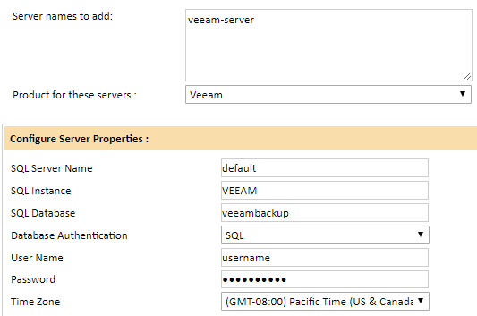

### Field Definitions

#### Server name to add

This must be the name of the Veeam Backup and Recovery Server. If in a cluster, use the cluster name not an individual node name.

#### SQL Server Name

Provide the name of the server where the Veeam database resides, leave as default if the database resides on the same server in which the Veeam application is installed. If in a cluster, use the cluster name not an individual node name.

#### SQL Instance

Provide SQL instance where the Veeam database resides. By default, the Veeam database is installed on the instance *Veeam.* **Note:** If installed on the default instance (MSSQLSERVER) leave this filed blank

#### SQL Database

Provide the Veeam SQL Database name. The default name is veeambackup.

#### Database Authentication

Choose Windows or SQL Authentication depending on the type of User that will be used to access the Veeam database.

#### User Name / Password

Enter the credentials for the SQL or Windows Authenticated user that has permission to run SELECT queries against the Veeam database.

#### Time Zone

Select the time zone where Veeam server resides. This setting ensures times are displayed consistently in environments that span multiple time zones.

# Reporting Notes

Any Veeam reporting notes will be entered here.

# Troubleshooting

As troubleshooting information is discovered it will be entered here.

# Technical Support

For technical support or a copy of our standard support agreement, please contact us.

**E-mail:** [support@bocada.com](mailto:support@bocada.com)

**Support Portal:** <https://bocada-support.force.com>

**Phone:** +1-425-898-2400

**Copyright © 2022 Bocada LLC.** All Rights Reserved. Bocada and BackupReport are registered trademarks of Bocada LLC. Vision, Prism, vpConnect, and the Bocada logo are trademarks of Bocada LLC. Other product names mentioned herein may be trademarks or registered trademarks of their respective companies.

Protected by U.S patents 6,640,217; 6,708,188; 6,745,210; 7,457,833; 7,469,269; 7,496,614; 8,407,227

The material in this manual is for information only and is subject to change without notice. While efforts have been made to ensure accuracy, Bocada LLC assumes no liability resulting from errors or omissions in this document, or from the use of information contained herein.

Bocada LLC reserves the right to make changes in the product design and documentation without reservation and without notification to its users. 2022-05-05